**Log Transformation**

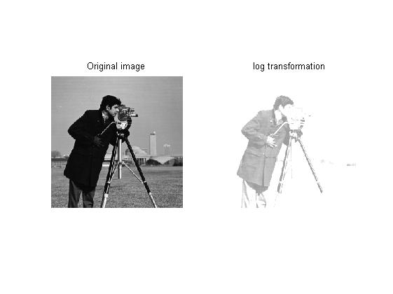here,c=70

* Image is transformed by transformation function:

b=c*log(1+a)

where

c is a constant deciding contrast enhancement

a is every pixel of original image

b is pixel of output image

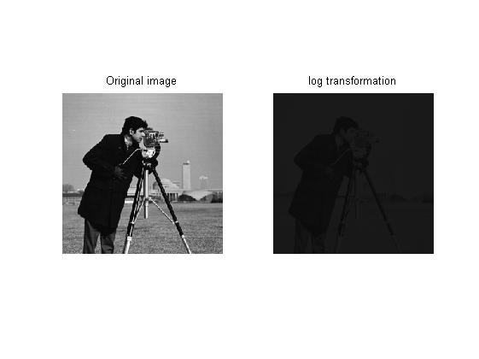here c=5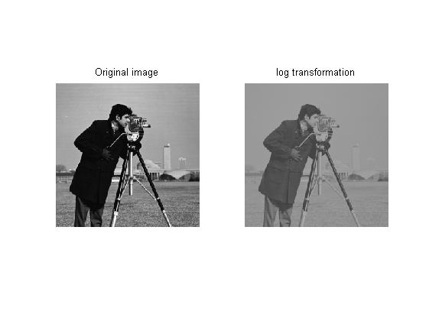here c=30

here c=70

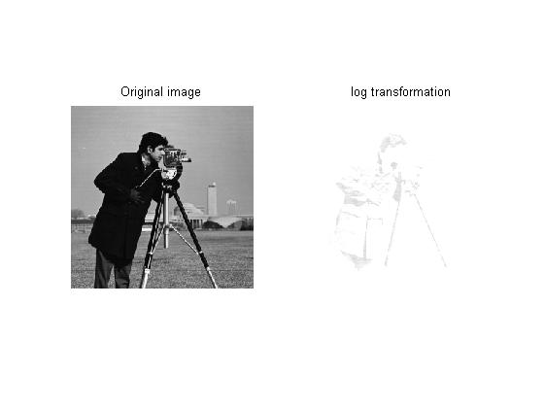here c=100

* We observed as the c value is increased, the pixel value lie more closer to white ie intensity value of 255.
* Also, the black values, 0 are more visible after transformation like the coat of cameraman. Mostly, grey or white values get close to 255 and appears white.